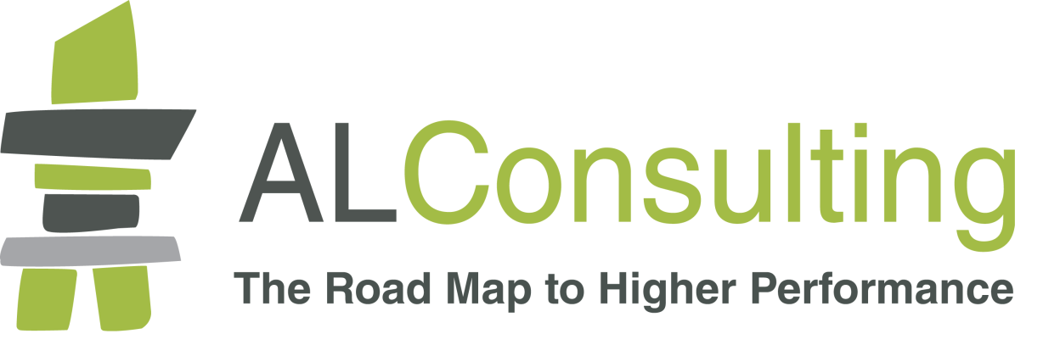

Business Health Check
Workbook

Name: ……………………………………………………………

Date: ………………………………….

INTRODUCTION

The purpose of this workbook is to guide you through the Road Map to Higher Performance process in a logical and structured way. You will find it helpful to read the booklet The Road Map to Higher Performance beforehand. For your free copy email info@al-consulting.co.uk

The workbook covers each of the four stages namely:

Business Challenge Mapping which:
- refreshes your business vision
- realigns values and behaviours
- identifies your highest priority objectives
- defines the critical success factors necessary to achieve them
- ensures that conditions essential for success are clearly understood.

Organisation Fit for Purpose which looks firstly at the validity and effectiveness of your business model and then reviews the systems and processes necessary to make it perform at a higher level. These include performance data collection and essential management information.

Lean Management which:
- eliminates unnecessary resources and paperwork that clog up your business, thereby increasing efficiency
- maps each stage of every management and administration system to identify those that add value and those which are simply a costly waste
- clearly identifies what actions need to be taken to improve performance and reduce costs.

An Engaged Workforce which develops an environment where employees enjoy their work and contribute more productively to the business by:
- defining the specific skills and knowledge your people must have in order to deliver higher performance
- aligning the development of people with the development of processes
- identifying cost-effective approaches to development, making use of relevant
work-based learning opportunities
- providing effective performance management.

Whilst addressing any stage of the Road Map to Higher Performance can produce measurable benefits, the most effective approach is to start at the beginning and follow the route.

The Road Map to Higher Performance is not a race. It is more like a treasure hunt where those who take their time to fully explore their environment will find the hidden treasures.

The end product of the Business Challenge Mapping process will be an effective strategic business plan that is shared, owned and driven by all the business’s stakeholders, which includes the employees.
Business Challenge Strategic Road Map
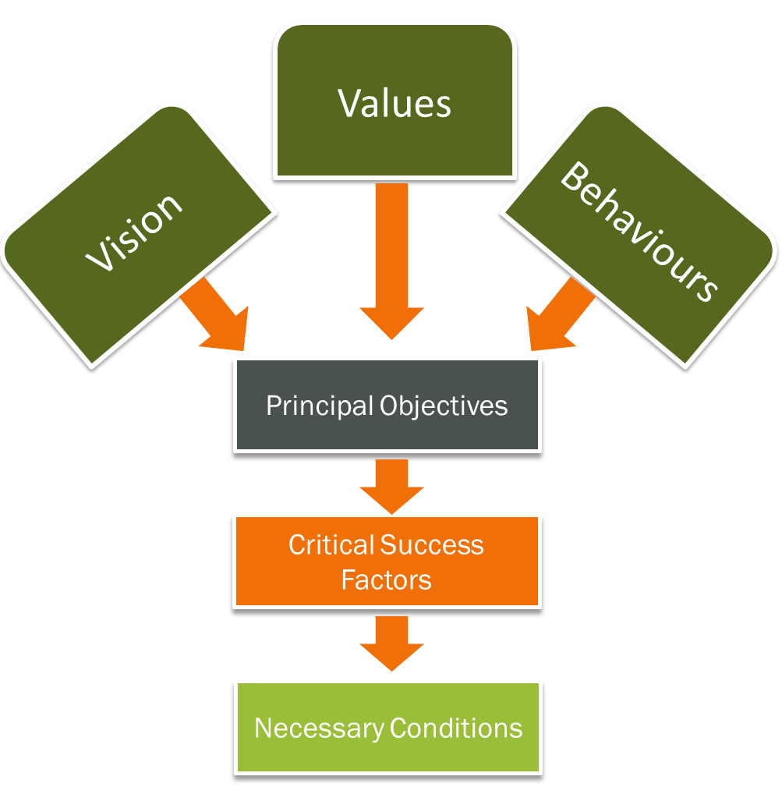

Complete this workbook and return it to us and we will produce a strategic road map for you, at no cost, and arrange a free consultation of up to half a day, to advise you on how best to implement it.

Either post the completed book to:
A L Consulting, High Tarn, Aughton, Lancaster, LA2 8LU
or
email it to info@al-consulting.co.uk

Vision
A Mission Statement explains the purpose of an organisation and why it exists, whereas a Vision Statement explains what the business wants to become or achieve in the future.
The vision for the business can be explained simply and succinctly in a way that will fully motivate the staff to support it.

Describe the specific and measurable terms the business wants to achieve:
- In the next year

- In the next 3-5 years

Values and Behaviours
Values set out the internal rules or ethics which define the business’s culture and direct the ways in which it operates. Behaviours are the ways in which staff carry out their duties.
Using the following template, explain what each of the business’s values actually mean, the behaviours that actively support it and those that will undermine it
VALUE

What the value actually means

Behaviours that support the value: | Behaviours that undermine the value:

VALUE

What the value actually means

Behaviours that support the value: | Behaviours that undermine the value:

VALUE

What the value actually means

Behaviours that support the value: | Behaviours that undermine the value:

VALUE

What the value actually means

Behaviours that support the value: | Behaviours that undermine the value:

VALUE

What the value actually means

Behaviours that support the value: | Behaviours that undermine the value:

Principal objectives
Principal objectives are the vital things that a business has set itself to achieve within a stated time frame. They must be SPECIFIC, REALISTIC AND MEASURABLE otherwise they are just aspirations.
The business’s principal objectives are:

1.

2.

3.

4.

Compatibility
Explain how each principal objective is compatible with the business’s vision and values.
Principal objective 1

Principal objective 2

Principal objective 3

Principal objective 4

Business metrics
How is the business going to measure its progress towards each of its principal objectives? This should not only include not what factors you are to be measured but how and when they are be to measure them and the base line from which measurement will be compared
Principal objective:

What will be measured:

How this will be measured:

Principal objective:

What will be measured:

How this will be measured:

Principal objective:

What will be measured:

How this will be measured:

Principal objective:

What will be measured:

How this will be measured:

Critical success factors
Describe the critical success factors relating to each principal objective.
Principal objective:

The critical success factors for this principal objective are:
1.

2.

3.

4.

5.

Principal objective:

The critical success factors for this principal objective are:
1.

2.

3.

4.

5.

Principal objective:

The critical success factors for this principal objective are:
1.

2.

3.

4.

5.

Principal objective:

The critical success factors for this principal objective are:
1.

2.

3.

4.

5.

Necessary conditions
Describe the necessary conditions for the achievement of each critical success factor.
Principal objective 1

Critical success factors:
1.

2.

3.

4

5.

The necessary conditions for the achievement of this critical success factor are:

a)

b)

c)

d)

Principal objective 1

Critical success factors:
1.

2.

3.

4

5.

The necessary conditions for the achievement of this critical success factor are:

a)

b)

c)

d)

Principal objective 1

Critical success factors:
1.

2.

3.

4

5.

The necessary conditions for the achievement of this critical success factor are:

a)

b)

c)

d)

Principal objective 1

Critical success factors:
1.

2.

3.

4

5.

The necessary conditions for the achievement of this critical success factor are:

a)

b)

c)

d)

Return on investment
Before making any strategic business decision, you should clearly understand why you are making the decision and what business benefits will accrue. Benefits can be tangible or intangible and may require further investment to be sustainable. The nature of the investment can range from expenditure on capital items to time given for training or addressing work-life balance.
Whilst calculating the return on your investment may not be an exact science, as it does require some assumptions to be made, failing to do so means that you are not investing, merely gambling.
Principal objective 1

Resources required:

Expected benefits:

Principal objective 2

Resources required:

Expected benefits:

Principal objective 3

Resources required:

Expected benefits:

Principal objective 1

Resources required:

Expected benefits:

AN ORGANISATION FIT FOR PURPOSE

An organisation fit for purpose is based around having a valid business model that sets out the fundamental basis on which the business operates. For example, a retail shop buys goods from suppliers and sells them at a profit to customers who come into the shop. A manufacturing business will convert raw materials into a manufactured product and either sell it on to another manufacturer or to a wholesaler or retailer.

Our business model is:

Now answer the following questions:

What evidence is there that we sell our goods/services at a price that will generate a gross profit?

What evidence do we have that we have the capacity to generate sufficient gross profit to ensure a net profit?

What evidence do we have that the net profit will produce an adequate return on the investment?

How far can we reduce our selling prices and still generate a net profit which produces an adequate return on the investment?

Can we use technology to reduce our operating costs?

Do we have adequate management information to keep us informed about what is going on in the business?

Can we identify and address threats to the business, such as changing buying patterns or new products and services which make ours obsolete, before they become critical?

When did we last review the data behind our answers to these questions?

What are we doing to ensure our business model remains aligned to our customers’ buying preferences? (i.e. we monitor our activities to anticipate strategic drift).

Are there any imminent changes or advances in technology that might threaten the effectiveness of our business model?

Is our business model scalable? In other words, can we increase turnover without increasing costs proportionately?

If yes, what evidence do we have to support this?

Risk assessments
Risk is inherent in doing business and the best way not to fail is never to take any risks. Some risks are obvious such as fire, public liability and theft. Others are less obvious and may be overlooked. What precautions have you got in place against the following risks?

Risk from competition
- competitors bringing new products into the market,

- replacements to your offering,

- competition that is cheaper, better, etc.

Market risks
What are the possibilities that a change in customer buying patterns or new technology could materially damage your market?

Talent risk
What is your strategy for effectively recruiting, developing and retaining a succession of talented staff?

IT risks
How do you ensure that the technologies you use are current and effective in communicating with your customers?

What back up plans do you have in the case of failure of any, or all, of your critical systems?

Financial risks
What are the major risks of, and how would you effectively manage:

- Loss of a major client?

- A very large bad debt?

- Withdrawal of bank support?

- Loss of a critical supplier?

- A large claim against you?

Innovation risks

What innovations in the foreseeable future are likely to have an impact on:
- The products and services we offer?

- The ways in which we produce or deliver our products and services?

How do we monitor potential innovations to evaluate when they are likely to have an impact?

Relationship risks

What are your contingency plans should you lose:
- A critical partner?

- A supplier of an essential product or service?

- A key distributor?

Reputation risk

In the Internet age, your reputation moves at the speed of Twitter, Facebook, and other social medias. It takes far less time to destroy a reputation than to build one. What possible threats could damage your good reputation?

a)

b)

c)

d)

e)

For each risk you identify, ask yourself:
- How likely is this to occur? Rate each risk and assign priority to its management.

- How can I manage this risk?

- How can I prevent this risk?

Business continuity
Risk assessment focuses on identifying potential risks and taking steps to avoid them or mitigate the losses should they occur. Business continuity is about devising strategies and plans for continuing in business should one or a combination of risks occur. Losing stock to flooding is one thing. Long term loss of your business premises, computer systems, key staff etc is quite another. Having well thought out plans which are regularly reviewed and tested could enable you to remain in business.

What are the major risks to your business continuity and what plans do you have to minimise the impact should they occur?

1)

2)

3)

4)

5)

6)

Organisational functions
Organisational functions are those activities necessary to make and keep a business successful and are exactly the same, regardless of the business’s size! In large organisations a particular function might require a sizeable team, whereas in a small business it might only form part of one person’s duties. The point is that unless someone carries out every role, the business has one or more blind spots which could well be overlooked until there is a problem, and by then it might be too late to fix the situation.

Policies
What policies do we need and have we got them?

How often do we review our policies?

Do we review our policies at sufficiently senior level?

Social responsibility
Do we have a social responsibility policy and if not, why not?

Who is responsible for creating our social responsibility policy and how often do we review it?

How is our social responsibility policy communicated to staff and how are they encouraged to engage in it?

Human Resources
Do we have a human resource plan, and if not, why not?

Does it cover:
- Appropriate terms and conditions for all staff?

- Current and future manpower requirements?

- Training and development?

- Succession planning?

Who is responsible for producing our human resource plan?

How frequently is our human resource plan reviewed and is this adequate?

Health & Safety
Do we have a fully compliant health and safety policy signed off by the most senior directors or managers?

Do we carry out risk assessments of all parts of our organisation at least annually or after any change?

Do we make all staff aware of the risks associated with their areas of work?

Who is responsible for ensuring that risk assessments take place and are carried out effectively?

Compliance
What laws, licensing and mandatory regulations do we have to comply with?

What voluntary protocols and codes of practice have we agreed to comply with?

What procedures do we have in place to comply with these requirements?

How do we audit these procedures?

Strategic planning
Do we have a strategic plan, and if not, why not?

Who is responsible for producing our strategic plan?

How frequently is our strategic plan reviewed and is this adequate?

Technology reviews
Who is responsible for reviewing the effectiveness of the technologies we use?

How often are reviews carried out?

How do we monitor the emergence of new, relevant technologies?

Performance metrics
What performance metrics do we use and are they sufficient for our needs?

Who ensures that they are accurately and timely maintained?

How are the results effectively communicated to all involved in generating them?

Business plan
Do we have short and medium term, comprehensive business plans which set out specific and measurable objectives?

How have these been communicated to all staff?

How will performance against them be monitored and reported?

Budgets
Do we have budgets for all departments for the year ahead?

Who produced them?

Are they monitored monthly and by whom?

Are variances reported to all members of the senior management team regularly?

Key performance indicators
Do we have key performance indicators which underpin the objectives in the business plan and the budgets?

Have these been communicated to all involved?

Is performance against the key performance indicators being communicated regularly to those affected by them?

Marketing
Do we have a marketing policy and strategy and if not, why not?

Who is responsible for creating our marketing policy and strategy and how often do we review it?

How is our marketing policy and strategy communicated to staff and how are they encouraged to engage in it?

How do we measure the effectiveness of our marketing policy and strategy?

Market research
Is our marketing policy and strategy based on sound and effective research?

How do we know it is?

How could this be improved?

Sales forecasts
Do we have a sales forecast for the year ahead?

Who produced it?

Is it monitored weekly or monthly and by whom?

Are variances reported to all members of the senior management team regularly?

Sales approaches
How are sales approaches reviewed to ensure that they remain fit for purpose and fully in line with customers’ changing buying requirements?

Complaints
How are complaints received recorded?

How are complaints investigated and by whom?

Who decides/authorises actions taken to resolve the complaint?

Does senior management review complaints and take steps to prevent their
re-occurrence?

Procurement
Do we have a procurement policy and strategy and if not, why not?

Who is responsible for creating our procurement policy and strategy and how often do we review it?

How is our procurement policy and strategy communicated to staff and how are they encouraged to engage in it?

How do we measure the effectiveness of our procurement policy and strategy?

Production or service delivery
How do we ensure that all our products and services:
- meet the agreed specification?

- are delivered on schedule?

- match the quoted price?

- provide value for money?

- are fit for purpose?

Control of materials
What procedures do we have for the effective control of:
- Goods and services inward?

- the issue of materials internally?

- stocks of materials?

- deliveries of products to customers?

Accounting and administrative processes
We have processes in place to cover:
- sales and order processing

- invoicing

- credit control

- payments of invoices

- pay roll

Management accounts
We have management accounts with sufficient detail to provide management with accurate and reliable financial information on a regular basis. These include:
- actual finance performance compared to budgeted performance

- explain the reasons for any variances

- the cash flow and liquidity position of the organisation

Management reports
Every monthly or 4 weekly interval, our managers are provided with a report that sets out:
- Performance metrics

- Management accounts

- Marketing and Sales reports

- HR data

- Health & Safety data

- Any other relevant information

LEAN MANAGEMENT
Waste is not always obvious and it is the hidden wastes which often produce the greatest losses or inefficiencies
The waste of overproducing
We have identified the following areas of overproducing:

We plan to address them by:

The waste of waiting
We have identified the following areas of waiting:

We plan to address them by:

The waste of over-producing
We have identified the following areas of over-production:

We plan to address them by:

The waste of inventory
We have identified the following areas of too much inventory:

We plan to address them by:

The waste of motion
We have identified the following areas of unnecessary movement:

We plan to address them by:

The waste of correction
We have identified the following areas of unnecessary re-working or correction:

We plan to address them by:

The waste of transport
We have identified the following areas of unnecessary transport:

We plan to address them by:

Mapping the value streams
We have identified our three main value streams as:
1)

2)

3)

We plan to map them by:
1)

2)

3)

We have identified the current and future state of each value stream as :
1)

2)

3)

Mapping the value streams
We have identified the following members of each value stream mapping team as:
1)

2)

3)

We plan to give all the members of each team the following training:

AN ENGAGED WORKFORCE
Employee engagement is a workplace approach designed to ensure that employees are committed to their organisation’s goals and values, motivated to contribute to organisational success, and are able at the same time to enhance their own sense of well-being.
Staff surveys
We regularly survey staff opinion using the following techniques:

We communicate the outcomes of each staff survey to all staff by:

Vision and values
We regularly refresh our vision statement and communicate it effectively to all employees by means of:

We have created a “golden thread” model which sets out our objectives and shows how each individual’s role links into one or more objectives. We have shared this with all staff through:

Communications
We regularly:
- brief all employees on the “state of the nation”

- use team meetings to reinforce the briefing messages

- Use team meetings to encourage people to participate in the management of their areas of work

Empowerment
We have developed operational parameters or standard operating procedures for all roles and communicated them to staff through:

We actively encourage line managers to be “hands off” rather than “hands on” by:

We involve our staff in developing corporate values and defining the behaviours that underpin them through:

We ensure managers display the values and behaviours at all times by:

Recognition
We regularly recognise the efforts of our people through:

We celebrate individual, team and organisational achievements by means of:

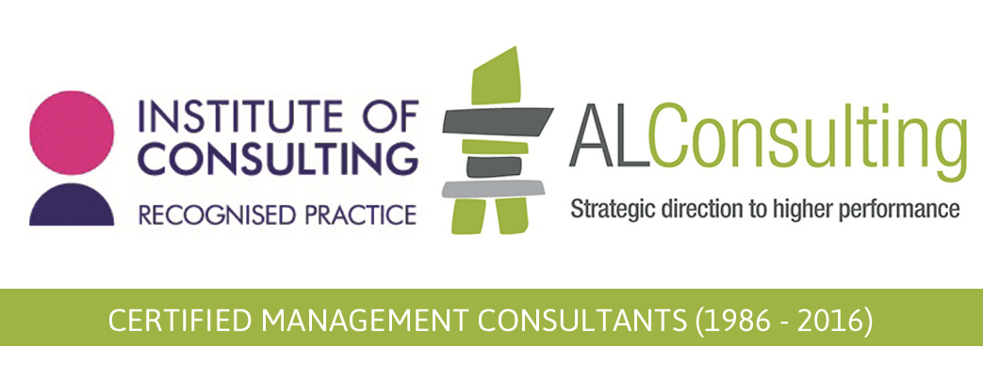
High Tarn, Aughton, Lancaster, LA2 8LU
Tel: 01524 811890 Email: fred@al-consulting.co.uk
www.al-consulting.co.uk

